Welcome
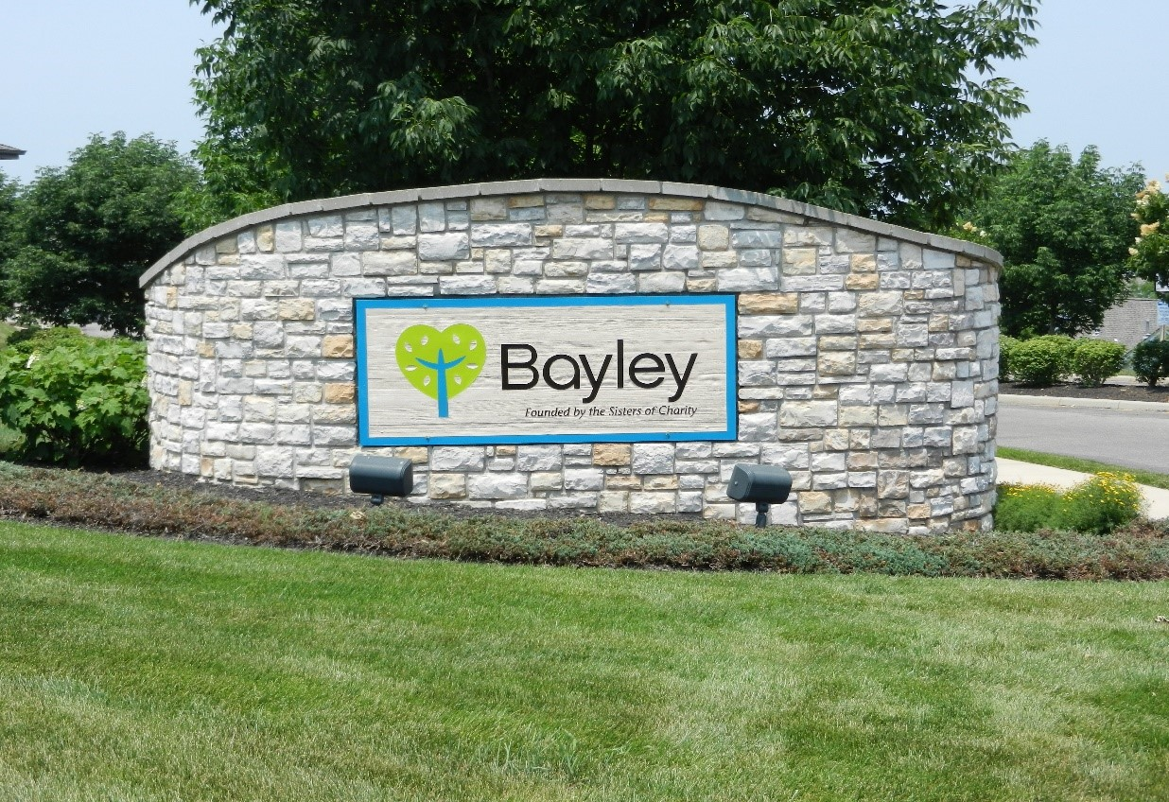

Bayley Village
Resident Handbook

BAYLEY VILLAGE RESIDENT HANDBOOK

Welcome 5
Mission Statement 6
Philosophy 6

Village Policies/Practices/Activities
Activities 7
Appliances 7
Automobiles /Boats/RVs/Campers 7
Cable 7
Check-in 7
Children 8
Clutter 8
Conference Room Reservations 8
Contributions/Sharing of Gifts 8
Cottage Damages 8
Decorating 8
Emergency Preparedness 9
Flags 9
Garden Areas 9
Grills 9
Home Services 9
Lake/Park 9
Mail Slots 10
Maintenance 10
Maintenance Inspection 10
Meals 10
Monthly Fees 10

Outside Ornamentation 10

Painting 10

Parking 11

Pest Control 11
Pets 11

Phones 11

Priority Placement 11

Religious Services 12

Security 12

Smoke Detectors 12

Snow Procedures 12

Solicitation 12

Speed Limit 12

Tornado 12

Transportation 12

Trash and Recycling 13

Utilities 13

Vacation 13

Visitors 13

Volunteer Opportunities 13

Walking Trails 13

Wall Hangings 13

Wellness Center 14
Window Coverings 14

Phone Numbers 15-16

Genesis of the Village 17-21
Notes 22

WELCOME TO BAYLEY VILLAGE
We are so glad you’re here!
The Sisters of Charity have provided significant health care, education, and social services to the Cincinnati area for many years. We, at Bayley Village, intend to carry on this Sisters of Charity tradition in service to our residents.
This handbook is designed to help answer some of your questions. No handbook can answer every question, but this is the best place to start. Please take your time reviewing each section to better acclimate yourself with resources available to you as a resident of Bayley Village.
If your answers are not found in this book, please don’t hesitate to call the appropriate department, as outlined in the following pages.
This booklet gives information about operational policies, activities, resources, and contacts. There is a wide variety of interesting opportunities and we encourage you to try any and all that appeal to you.
We hope that you will find Bayley Village a safe, comfortable, and enjoyable place to live.

MISSION STATEMENT
Bayley Senior Care provides a continuum of care for seniors in a Catholic/ Christian environment. As founded by the Sisters of Charity, we strive to provide compassion and quality of life to those we serve. Our commitment is rooted in the values of respect, honesty, and excellence.

PHILOSOPHY
We believe that the senior care ministry is a valid expression of the mission of the Church today.
We believe in a holistic, integrated ministry that contributes to the well-being of seniors regardless of race, color, national origin, creed, sex, and socioeconomic status.
We believe in the sacredness of each person, and reverence of the individual striving for self-determination of each state of life.
We believe in providing innovative quality services and programs that contribute to the well-being of the whole person.
We believe in the value of transitional services, which nurture independence and are responsive to the unique needs of seniors.
We believe in our responsibility to speak and respond to issues related to the rights of seniors and to effect changes within society which leads to a fuller life for all seniors.
We believe in those values, principles and goals inherent in the medical-moral teachings of the Church.
We believe professional excellence and competence should be pursued by all persons giving care and services.
We believe professional excellence and competence are basic to all programs designed to enhance the delivery of senior care services.
We believe in responsible stewardship to maximize use of resources.
We believe in effective leadership to develop creative, integrated forms of service.
We believe that education, training, and research are important aspects of improving the quality of life and should be carried out in a manner which recognizes an individual’s privacy, dignity, and lifestyle.

Village Policies/Practices/Activities
Violations of the policies listed herein will be subject to review and resolution by Bayley Administration on a case-by-case basis.
Activities: A variety of social, educational, and volunteer activities are available to the residents of the Village, such as Game Night, Happy Hour, Ladies’ Lunch, Men’s Lunch, etc.
In addition to the regular schedule, there are parties, picnics, cookouts, games, and day trips to places of interest. These typically require an RSVP.
Refer to the monthly calendar, which is placed in your Wellness Center mail slot, for details on each event. The calendar comes out on the first of each month. This information will be in the Resident and Family Portal as well.
https://familyportal.bayleylife.org/
Appliances: The Village will provide and maintain the following appliances for each cottage: Washer/dryer, refrigerator, stove, dishwasher, microwave oven, and garbage disposal. Residents are able to purchase their own appliances, however Bayley will only maintain or replace appliances that are furnished by Bayley.
Automobiles: Resident automobiles should be in proper working condition. To ensure a lovely community, please avoid any automobiles that might be a possible eyesore.
Boats/RVs/Campers: Such vehicles should be parked in the resident’s garage or stored off-site at the owner’s expense.
Cable: Residents may obtain cable service with a local cable provider. Each resident is responsible for cable-related charges. All cottages are cable ready.
Satellite dishes are permitted but check with Bayley Administration at 513-347-5520 before installing for additional information. Cable companies must clean up after themselves, including maintaining the cable utility boxes they may open.

Check-In: A daily check-in is linked to your emergency response system to provide additional resident safety and security. Please push the “daily check-in” button located in the master bathroom each morning between 5:00am and 11:00am. If you have not checked in by 11:00am, the Reception Desk at Bayley will call your home. If no answer is received, Bayley Security will come to your home to check on your safety. If you will be away from your cottage overnight or between the hours of 5:00am and 11:00am, please notify the Bayley Reception Desk at 513-347-5500 in advance.
Time away from the cottage, such as vacations, hospital stays, etc. should also be reported to the Bayley Reception Desk. Any resident that does not wish to partake in the daily check-ins can remove themselves at any time.
Children: Children under the age of 18 must be supervised at all times. Children are not permitted to use the Wellness Center.
Clutter: To ensure a lovely community, the exterior of each cottage should be kept free from clutter. For the safety of the resident, the interior of each cottage should be kept free from clutter as well.
Conference Room Reservations: Residents may reserve rooms within Bayley and the Wellness Center for private parties or functions subject to availability and some fees apply. Please call 513-347-5500 for assistance in reserving an available room.
Contributions/Sharing of Gifts: Charitable giving plays an important role in the lives of many people. Making a gift to Bayley is a way that a donor can invest a portion of his/her resources in the future of our efforts here, and also realize possible tax benefits. There are many types of planned giving vehicles that enable a donor to remember his/her favorite charity through effective estate planning. Honorariums and memorial gifts are meaningful ways to preserve the memory of a loved one or add significance to birthdays, graduations, anniversaries, or other special occasions. For more information about charitable giving or memorial gifts, please contact the Bayley Development Department at 513-347-5735.
Cottage Damages: If a resident moves out of a cottage leaving extensive damage to the interior and/or exterior, the Village reserves the right to withhold a portion of the resident’s initial entrance fee in an amount equal to the cost of repairs.
Decorating: After taking occupancy, if residents desire a different paint color, stenciling, etc., they are responsible for purchasing supplies and doing the work themselves. Residents are permitted to hang a wallpaper border, but full wallpaper covering is not permitted. When refurbishing a cottage for the next occupant, Bayley will charge to remove wallpaper borders or excessive paint.

Emergency Preparedness: There are emergency response buttons and a pendant located within each cottage. When an alarm is activated the notification goes to a security system in the Bayley Health Care building as well as the Security cell phone. Each cottage has an emergency strobe light above the garage that will activate when the emergency response system is triggered as well to provide direction for emergency assistance providers. Bayley staff will call the resident immediately. If the resident does not respond to the call within 5 rings Security will be dispatched. If a true emergency is identified 911 will be called. The pendant provides this same service except that it is on a neck chain, making it portable. It covers the Village campus area east of Bender Rd. Each pendant is electronically connected to your address.
The call system pull-cords in the cottages have battery backups and the pendants run on batteries. Both will work in the event of a power outage. If the power goes out at Bayley and the generator kicks in, the system will still work.
Flags: Residents are allowed to have American flags in their yards, but they must be displayed properly. Please call Maintenance for installation assistance.
Garden Areas: Residents may add seasonal flowers to their existing landscape. Vegetables may be planted along the side or back of the cottage. Any additional plants must be approved by Bayley Administration at 513-347-5520 and maintained by the resident. All plantings should be in the mulched areas about 12˝ from the grass line, so as not to interfere with the grass cutting.
Grills: Residents may use grills. The grill must be outside and closely supervised at all times while in use. Residents are responsible for safety and maintenance of any external cooking devices.

Home Services: Bayley Home Services is an in-home, fee-based assistance program available to Village residents as a way to ensure an individual’s needs are met while still maintaining the freedom he/she desires. Bayley Home Services provides private pay, non-medical care. We can help with personal care assistance, laundry, medication reminders, and light housekeeping, amongst other things. For more information or to schedule an in-home service appointment, call 513-347-4168.

Lake/Park: All guests must be accompanied by a resident when enjoying activities at the lake and/or park. The Village is not responsible for injury to a resident or visitor occurring as a result of negligence or lack of supervision on the grounds of the Village.

Mail Slots: There are mail slots for each address located in the Wellness Center for in-house mail. These are referred to as “Wellness Center Mail Slots.” Please check your mail slot on a regular basis for campus information.
MAINTENANCE:
*Non-emergency: If a non-emergent maintenance issue arises, please call 513-347-5600, Option 3. This line will be checked throughout the day Monday-Friday.
*Emergency: If an emergency maintenance situation arises at any time, please call 513-207-0954.
Maintenance Inspection: Each cottage will undergo an annual inspection of Village-provided structure and equipment. Residents should be present for these inspections and will be scheduled as such. Only Bayley-purchased items are eligible for inspection.
Meals: Lunch and dinner delivery are available to your cottage Sunday through Saturday! Lunch is served 11:00am-1:30pm and dinner is served 4:30pm-6:00pm. If you would like to order a meal, please call food services 2 hours in advance at 513-347-5516. Ask for a Supervisor to place the order and let them know the day, date, type/number of meals requested. It is necessary to keep a credit card on file to order meals. Call the same number to set that up in advance of ordering meals.
Monthly Fees: A drop box for monthly fees is available in the lobby of the Wellness Center for your convenience. Automatic checking account deductions can also be arranged via ACH. Contact the Business Office at 513-347-1407.

Outside Ornamentation: Small garden ornamentation is permitted within the landscaping (mulched area). Large ornamentation (such as awnings, window boxes, and plastic brightly colored lawn decorations) are not permitted. Bird feeders are permitted as long as they do not interfere with lawn maintenance and neighboring areas. Residents are welcome to display holiday decorations, however all decorations must be temporary in nature and must not be permanently attached to any part of the building or structure. All holiday lights must be removed within 30 days after the end of the holiday season. Please call Maintenance if you have specific questions about holiday displays.
Painting: Routine painting of cottage interiors using a selection from our approved color palette will be scheduled as needed. Any resident requests for interior painting for aesthetic reasons is subject to Administration approval. Call 513-347-5600, Option 3, to submit a request. Pricing for these requests will be handled on a case by case basis.

Parking: Residents must park their vehicles in their garage or driveway.
Visitors may use the additional Village parking spaces, Wellness Center, or Bayley parking spaces. If it is necessary to park on the street for a short time, please avoid parking next to mailboxes or directly across from driveways. No overnight parking is permitted on the streets. Parking on Mattingly next to the Wellness Center is not permitted. When parking in driveways please also be mindful to pull up enough so that sidewalks are not blocked for pedestrians.
Pest Control: Routine preventative maintenance is performed annually to the outside of the cottages. If residents have an insect problem in their cottage, a work order should be submitted to 513-347-5600, Option 3. The order will be directed to Environmental Services for scheduling. Residents are responsible for maintaining a sanitary living environment to help prevent pest infestations. Any pest issues arising from a resident’s actions, negligence, or failure to maintain cleanliness will be the financial responsibility of the resident.
Pets: Residents who own a family pet are welcome to bring their pet. All dogs must be leashed and cats are not permitted to roam free. No fences are permitted. Shots and vaccination records will be needed and must be kept up-to-date. A responsible party is to be named as a backup to the resident pet owner in the event emergency or custodial care of the pet is needed. Residents are required to scoop up and bag all “droppings.” For your convenience, two pet waste stations with bags have been installed in the Village. A one-time nonrefundable fee is charged per cottage with pets, and an agreement of understanding must be signed. Residents are allowed two dogs or up to two cats per unit. Some size restrictions do apply. Pets must be crated in order for staff to enter your cottage. As a courtesy to your neighbors, pets also must be quiet while inside your cottage and throughout the community.
Phones: Residents must provide their own telephone service. There are telephone jacks provided throughout the cottage for your convenience.
Priority Placement: Residents of the Bayley Village are considered for priority placement within Assisted Living or Nursing at Bayley and Bayley Adult Day Program over individuals from the outside community at large. If appropriate accommodations are not available, the staff will assist in procuring other services until accommodations become available.

Religious Services: Pastoral Care Services are provided to residents and families by Bayley Chaplains and Pastoral Associates. Our Chaplains and Associates are in house Monday to Friday 8:00 a.m. until 4:30 p.m. To contact a chaplain during those times please call 513-347-1382. For an immediate need after regular office hours (such as end of life services or anointings) call the Director of Pastoral Care at 513-470-7808.
Residents of Bayley Village may attend any and all of the religious services offered at Bayley, including Mass on Monday through Friday at 10:30am and Vigil Mass on Saturdays at 3:00pm. Call Pastoral Care at 513-347-1382 for a detailed leaflet on days and times.
The bus is available on Saturdays to take you to the 3:00 p.m. Vigil Mass in our Enrichment Center at no charge. Just turn on your porch light by 2:00 p.m.
Security: Merchant Security patrols the Village area 24 hours per day on weekends and holidays, and from 3:00pm to 7:00am weekdays. Security can be reached by calling 513-431-9194 from 7:00am to 3:00pm weekdays, and 513-207-0954 at all other times. Please be aware that in an abundance of caution, Security will close any resident garage door that remains open after 11:00pm.
Smoke Detectors: Each cottage is furnished with smoke detectors that are connected to the emergency response system, as well as CO2 detectors to enhance your safety.
Snow Procedures: Snow removal will be done in priority order. Resident safety is our utmost concern. Roadways and emergency access areas will be cleared first. Driveways and individual walkways will be cleared next and salt products applied as necessary. Thank you for your cooperation in allowing us to remove all snow as quickly as possible.
Solicitation: Solicitation is not permitted within the Village. If a solicitor comes to your door, please call Security at 513-431-9194 from 7:00am to 3:00pm on weekdays, or 513-207-0954 after those hours, weekends, and holidays.
Speed Limit: The speed limit throughout the Village is 10 MPH. Please drive carefully at all times and observe all traffic signs.
Tornado: In the event of a tornado/severe weather warning, Bayley recommends monitoring the National Weather Service and encourages residents to seek shelter in their bathroom or storage closet.

Transportation: If in need of transportation call 513-347-5540. We request 48 hours advance notice and will do our best to meet any last minute requests. There are fees associated with the use of Bayley Transportation.

Trash and Recycling:
Trash - To comply with our waste collection services contract, please use trash cans and line them with a large (32-gallon) trash bag before placing any other smaller bags or loose items in the can. Trash cans should be placed directly outside your garage door each Wednesday evening or early Thursday morning. The trash service will walk up your driveway to collect your trash bag(s) from the can. Please remember to store your trash can in the garage at all other times to avoid attracting wildlife.
Recycling – Bayley maintains one large recycling dumpster behind the Wellness Center that is available for all Village residents to use as they wish. There is no curbside Recycling service.
Utilities: Residents are responsible for their own Telephone, Gas, Electric, and Water bills. Bills for these utilities will be sent directly to residents, who are responsible for timely payment.

Vacation: Please notify the Bayley Reception Desk at 513-347-5500 when you are planning to be away from your cottage one day or longer so we may make note for security purposes.
Visitors: All visitors should be accompanied by a resident when enjoying activities on campus. Bayley is not responsible for injury to a resident or visitor occurring as a result of negligence or lack of supervision on the grounds. Residents will be held responsible for any damage caused by their guests. Visitors should abide by all policies. Visitors may not “live” with a resident in his/her cottage for more than ten (10) days at a time and no more than thirty (30) days in twelve (12) months, and must be pre-approved by Bayley Administration.
Volunteer Opportunities: There are many volunteer opportunities at Bayley,
Bayley Adult Day, and Bayley Wellness Club. There are all kinds of things to do: Eucharist Minister, transporting people, visiting residents, clerical, gift shop sales, hair salon, special projects, and much more. Please call 513-347-5416 for more information or to get involved.

Walking Trails: Please do not walk in the street. Use common courtesy when using the sidewalks and the inside and outside trails. You are responsible to clean up, if necessary, when walking a pet. Sidewalks and trails must be kept free of litter at all times. We encourage the buddy system when on the trails.
Wall Hangings: Maintenance is available to hang pictures, mirrors, etc. Call 513-347-5600, Option 3, and place a work order.

Wellness Center Promoting health and wellness for mature adults who live in the Cincinnati area. There are a variety of programs designed to keep you active and fit. A monthly schedule of programs and information on Wellness is available at the Wellness Center and on the Resident and Family Portal. As a resident of the Village, you are automatically a member. However, to be able to use the pool and exercise equipment, you must complete an application and medical health history consent form available at the welcome desk of the Wellness Center (513-347-1400). We also encourage you to stop by the welcome desk to register as a member, to provide your insurance information, and to obtain a scan card to sign into all classes and events.
Window Coverings: Residents may purchase window treatments of their choice along with the necessary hardware. The Maintenance staff will hang window treatments upon receiving a work order. To maintain a uniform appearance throughout the Village, all window treatments must have a white or beige color facing the street.

Bayley Phone Numbers:
General Village Questions 513-347-5520
Billing Information | 513-347-1407
Pastoral Care Department | 513-347-5525
Receptionist/Information (Bayley Front Desk) | 513-347-5500
Transportation | 513-347-5540
Volunteer Services | 513-347-5416
Wellness Center Front Desk | 513-347-1400
Work Order | 513-347-5600, Option 3

Note: A Village Phone Directory is available for your information and use.
It is updated frequently, usually on a quarterly basis, and placed in your Wellness Center mail slot. If you do not want your phone number listed, please advise Bayley Administration at 513-347-5520.

Delhi Township Phone Numbers:

Emergency 911
Police Dispatch 911
Fire or Life Squad Dispatch 911
Administration Offices 513-922-3111
Senior Citizen Center 513-451-3560

Other Possibly Helpful Area Numbers

AARP 1- 800 424-3410
Altafiber | 513-565-2210
Bureau of Motor Vehicles | 513-347-3440
Catholic Social Services | 513-421-7745
Council on Aging (Cincinnati Area) | 513-721-7670
Delhi Public Library | 513-369-6019
Duke Energy | 1-800-544-6900
Metro Bus System | 513-621-4455
Metro Fare Deal Card | 513-632-7540
Ohio Department of Aging | 1-800 282-1206
(Golden Buckeye) | 1-800 422-1976
Post Office | 1-800-275-8777
Voter Registration | 513-632-7040
Waterworks (of Greater Cincinnati) 513-591-7700


If a Village resident had turned off her TV and walked out on her front porch in the spring of 1867, she probably would have seen Mr. Biggs plowing his rolling fertile land with the help of his hard-working mule.
It was 1869 when the Sisters of Charity of Cincinnati bought the 100 acre Biggs Farm in rural Delhi. There they built their Motherhouse on the ridge overlooking the Ohio River.
Over time as more and more young women joined the order, and as more buildings were needed, they bought additional parcels of land. Now they own some 360 acres, including tracts of woodland on the ridge west of the Motherhouse. The land not occupied by the Motherhouse was farmed by hired men with the help of some of the younger sisters.
Since those early days the Sisters have assembled every four years for a Community Chapter. At these meetings the Sisters evaluate how the community is living out the specific vocation of the Sisters of Charity. At the Chapter of 1983 some Sisters proposed a response to the growing number of elderly people in this area. Committees were formed to investigate specific ways to take on this new work, and their findings were presented during the Chapter of 1987. There the community officially decided to move ahead.
There was a great deal of preliminary work to be done. The Sisters visited many other facilities to learn about the various possibilities. There were focus groups to discern the real needs of the older people. The Sisters talked with many different consultants, interviewed various planners, architects and contractors. They looked into possible conflicts with zoning regulations, and had town meetings with all the families who lived nearby. Only one man complained. He said his view of his farmland would be ruined! But when no serious obstacles appeared, the Sisters decided to use the land east of Bender Road to build a continuing care facility for senior citizens.
There was one bit of work to be done before construction could begin. The Sisters had rented the land to a man who kept cows in a large barn. He and they finally had to be evicted. The wood of the barn had weathered beautifully and a man from Indiana asked if he could have it. He dismantled the building and built a lovely home with it.
Construction was planned in three phases. The first building to go up, Phase One, was roughly the half of the Bayley Place closest to the Village. It opened in October of 1990 and was soon filled. In a short time authorization was granted for building Phase Two. This is the section of Bayley Place closer to Bender Road. It opened for service in July of 1995.
Phase Three included The Village, the Medical Center, and the Wellness Center. Construction of the Village began in July of 2000. Several designs were considered, one of which was the building of a three story apartment tower for independent living. But individual residences were seen as more compatible with the neighborhood. This construction was a major project. It required an enormous amount of earthmoving to convert rolling hills into streets and level places for homes and the Centers.
The 78 homes were to be built to standards above those required by the building codes – more sturdy and with heavier materials. The framing and roof trusses of Village homes were assembled at a factory, and the components of each home were delivered separately to each building site by truck. This required financing to the tune of some eighteen million dollars, with only the hope that residents would come
Just as the first residences were being completed, the attacks of September 11, 2001 occurred. Among many other terrible consequences, the stock market took a deep plunge. The Sisters saw the very real possibility that they would have these newly built expensive homes with no one able to move into them.
It was a time of high anxiety. But as everyone held their breath, the market slowly returned to normal and construction resumed.
Nora Hanseman was the first person to move in – September 27, 2001. She was surrounded by hundreds of men driving huge noisy machines, heavy trucks, countless dumpsters and acres of mud. But Nora hung tight.
Next resident was Omer Trippel and eventually we all followed. And it seems that every resident is very glad to be here.
(Special thanks to Sister Mary Ellen Murphy, President of the Sisters during most of this time, who consented to a lengthy interview.)

The Village Gets Organized
By 2002, with the noisy machines, trucks, dumpsters, hammers, saws and mud gone, the Village took on a new life. What was left were landscapers, lawnmowers, moving trucks, re-arranging furniture, picture hanging, meeting new neighbors and getting rid of all those never-used items that could be stored in obscurity in the ” house just vacated”. The Village came to life in a different way. It was now becoming our new “home away from home”.
Sr. Jeanne Roach, then President & CEO of Bayley Place, who managed this new brand of Retirement Living, was looking for a way to facilitate communication between residents and management, so she could get feedback from Villagers regarding their happiness and needs. At that time she consulted with Betty Malloy, a resident who had previous experience in this area, to assist her in developing such a “way”. A nine (9) member Task Force of residents was then assembled (Betty as facilitator, Jim Brady, Jim Eversole, Guy Hess, Ken Horney, Linda Mahlmeister, Bob Maxwell, John O’Connor, Betty Panzeca); and the by-product of that task force was the Village Council concept we are currently living with as outlined in the Bayley Village Constitution and By-Laws. Ratification by the Bayley Board of Directors (SCSCC) took place on December 6, 2004. Life was Good!
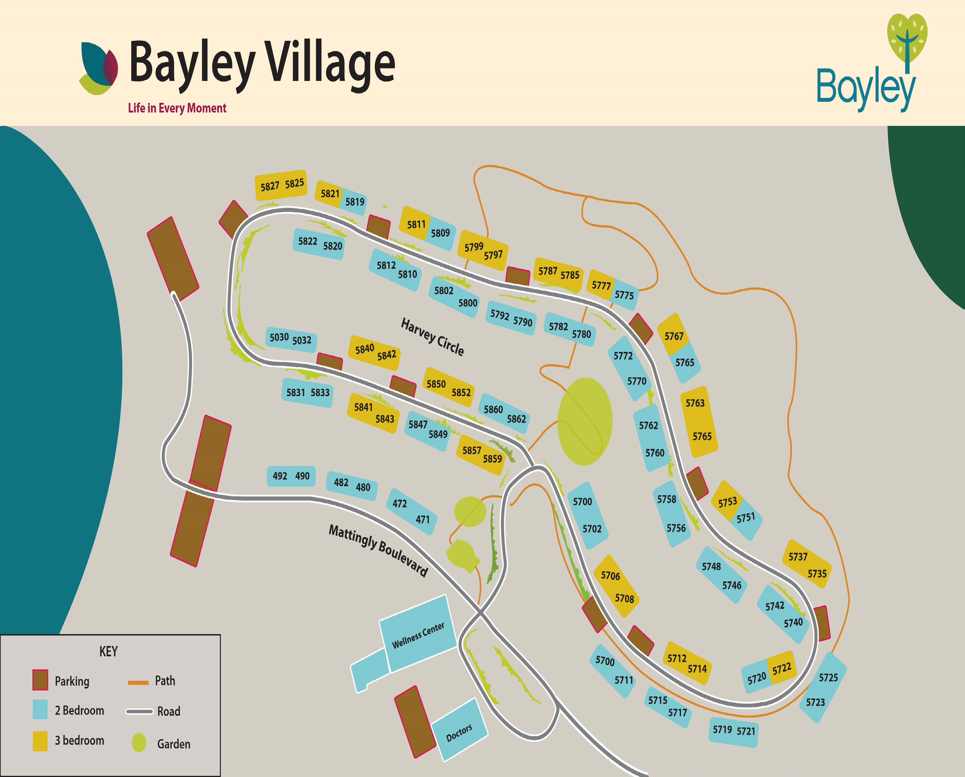

Notes

